
PROJECT REPORT
ON
PLACEMENT TRACKER – MERN

COURSE: MCA
SUBJECT: MERN STACK DEVELOPMENT (CA-3)

SUBMITTED BY:
MILIND NITIN CHAUDHARI
ROLL NO: 41
ERP NO: 25790607

DEPARTMENT OF COMPUTER APPLICATIONS
[Dnyaan Prasad Global Unitech Society]
ACADEMIC YEAR: 2025-2026
2. Project Summary / Overview
The Placement Tracker is a web-based application designed to help students manage and track their job or internship applications efficiently. In the current competitive job market, students apply to multiple companies for various roles. Keeping track of the status of each application (e.g., Applied, Interviewing, Selected, or Rejected) can become difficult using traditional methods like spreadsheets.
This project provides a centralized platform where users can log their application details, including the company name, job role, and current status. Built using the MERN Stack (MongoDB, Express, React, and Node.js), the application ensures a smooth and responsive user experience. Users can perform CRUD (Create, Read, Update, Delete) operations on their application data, allowing for real-time updates as they progress through different stages of the recruitment process.
3. Technology Stack
Component | Technology Used | Purpose
Frontend | React.js (Vite) | Building the user interface and handling client-side logic.
Backend | Node.js & Express.js | Creating the REST API and handling server-side logic.
Database | MongoDB (Atlas) | Storing application data in a NoSQL, document-oriented format.
Styling | Custom CSS | Designing a clean, responsive, and user-friendly interface.
State Management | React Hooks | Managing data flow and component lifecycle within the app.
API Communication | Axios | Sending HTTP requests from the frontend to the backend server.
Environment Config | Dotenv | Securing sensitive information like database credentials.

4. Software Requirement Specification (SRS)
4.1 Introduction
The purpose of this document is to outline the requirements for the Placement Tracker application. The system aims to simplify the process of tracking job applications for students, providing a clear view of their progress in the placement season.
4.2 Functional Requirements
- Add Application: Users should be able to enter the company name and the role they applied for.
- View Applications: The system must display a list of all logged applications in a table format.
- Update Status: Users should be able to change the status of an application.
- Delete Application: Users should be able to remove an application from their list.
- Filter Applications: The system should allow users to filter the list based on status.
- Data Persistence: All information must be stored securely in a database.
4.3 Non-Functional Requirements
- Responsiveness: The application should work well on both desktops and mobile devices.
- Performance: The app should load quickly, providing visual feedback during data fetching.
- Usability: The interface should be simple and easy to navigate.
- Reliability: The system should handle API errors gracefully without crashing.
4.4 System Architecture
The application follows a standard Client-Server Architecture: Client (React), Server (Node/Express), and Database (MongoDB Atlas).
4.5 Data Flow
User interacts with React frontend -> Frontend sends HTTP request -> Express backend processes request -> Database (MongoDB) is updated -> Response sent back to frontend -> UI reflects changes.

5. Screenshots Section
5.1 Home Page / Dashboard -
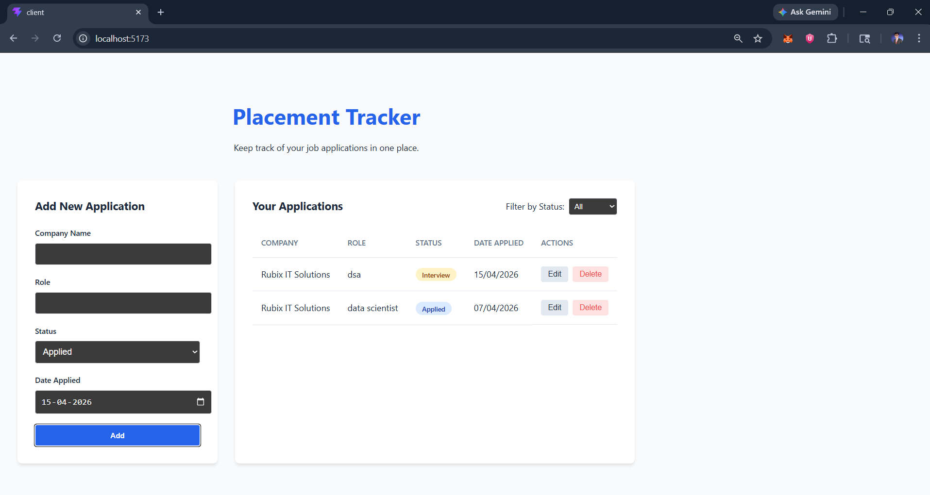
6. Conclusion
The Placement Tracker project successfully demonstrates the power of the MERN stack in building a real-world CRUD application. By automating the tracking process, the application helps students stay organized. Future enhancements could include user authentication and email notifications.
7. References
- MongoDB Documentation: https://www.mongodb.com/docs/
- Express.js Official Guide: https://expressjs.com/
- React.js Documentation: https://react.dev/
- Node.js Documentation: https://nodejs.org/en/docs/
- Mongoose ODM Documentation: https://mongoosejs.com/docs/

